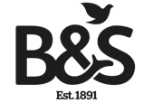
Bartholomew and Sons
Funeral directors for over five generations

Disclosure of Interests

- The ownership of Bartholomew and Sons Ltd is James Anthony Bartholomew and Janet Elizabeth Bartholomew.

- There is no business or material financial interest in a price comparison website.

- There has been no material charitable donation to a third party.

- There has been no charitable contribution or payment of gratuity to a third party.

- There has been no material form of payment to a third party that does not relate to a cost incurred or a service provided by the third party on behalf of or to Bartholomew and Sons.

